The Black Death – Great Plague
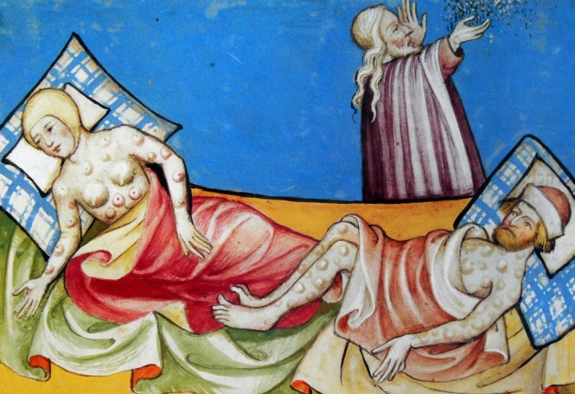
Today, you will be watching a documentary on the history of the Great Plague, also known as ‘The Black Death’. Listen and watch carefully. Take notes during the documentary to help you answer the questions below.
The Black Death
- When did the Black Death occur?

- How many people died in Europe from the deadly plague?

- Why did the plague kill so many people in places like Florence, Italy?
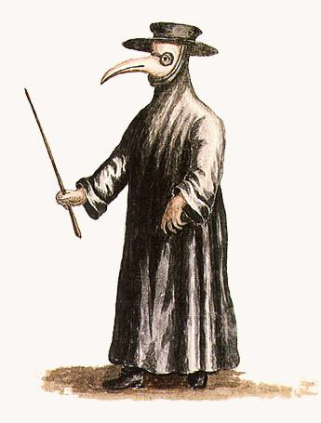
Causes, signs and symptoms
- What did people think caused the plague?

- What were the signs and symptoms of the plague?

- What sorts of methods were used to try and stop the disease?

- How did people treat the victims of the disease?
Society and culture in Europe
- What were some of the impacts of the disease on society and culture in European cities and towns?

- How many people died in Venice and Florence?

- What happened to the plague victims in the city of Sienna?

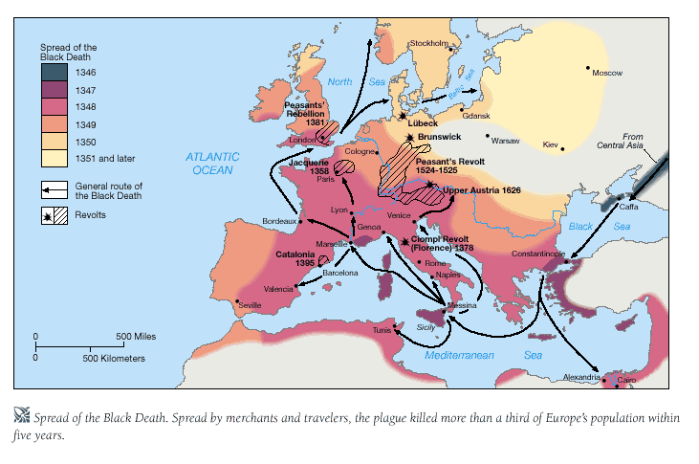
- What route pattern did the spread of disease follow?
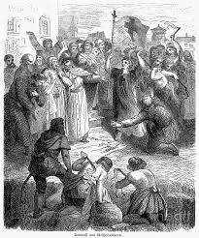
The Church and the Flagellants
- What did the religious people of Avignon believe to be the cause and reason for the disease spreading to their city?

- Who were the ‘Flagellants’ and what did they do?

- What opinion did the church have of the Flagellants?

- What methods did Guy De Chauliac believe prevented the Black Death?

- How were Jewish people treated during the spread of the plague?

- Why were Jewish people treated this way?

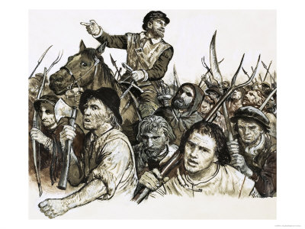
Life in England
- Which cities in England were the first places to receive the disease?

- Which members of the social hierarchy were victims of the plague?

- What were the advantages for peasant or merchant survivors of the plague?

- What impact did the plague have on the social hierarchy system in England?

European feudalism and culture

- How did European artwork change after the Black Death?

- What was life like in England and other European countries in the years after the Black Death?

